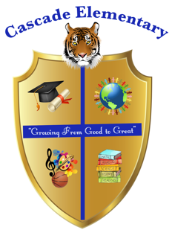

Cascade Elementary Website
Weekly Grade Level News Blast

Week of: Monday, May 18, 2020

Grade Level: 5

Standards of the Week:
ELA: Visiting places where ELA is used in careers.

Math: Visiting places where Math is used in careers.

Social Studies: Visiting places where Social Studies is used in careers.

Science: Visiting places where Science is used in careers.

Additional Information for Parents and Students:
It’s the final week of school!!! Congratulations parents, you got through it! We want to thank you for your hard work with students during this difficult time. We also want to thank you for being great partners all year long!

We are continuing our virtual classroom meetings Monday-Thursday at 11am because we are taking Virtual Field Trips around Georgia this week! View the code for your student’s individual teacher in the Google classroom main page.

Students will still have access to many of the apps they use for Reading and Math. Please have students access mybackpack.apsk12.org for continued reading on MyOn and Lexia activities or math activities on Prodigy and Dreambox.
Students have been using this all year in class so should have the username and password.

Additionally, we posted on the Google classroom some additional fun activities they can access through the summer on PBS Learning Media and some Social Emotional Learning activities on Mind Yeti.

If you need to get in contact with your student’s homeroom teacher please feel free to email:
Ms. O’Malley – jessica.omalley@atlanta.k12.ga.us
Ms. Adamu – ummulkhairi.adamu@atlanta.k12.ga.us
Mr. Spraggins – darrell.spraggins@atlanta.k12.ga.us

Have a wonderful summer!

